HW Question 01)

#include <stdio.h>

int main() {

int Score1, Score2, Score3;

int TotalScore;

float percentage;

printf("Enter the marks obtained in subject1 ");

scanf("%d", &Score1);

printf("Enter the marks obtained in subject 2 ");

scanf("%d", &Score2);

printf("Enter the marks obtained in subject 3 ");

scanf("%d", &Score3);

TotalScore = Score1 + Score2 + Score3;

percentage = (float)TotalScore/ 300 \* 100;

printf("\nTotal Marks are : %d\n",TotalScore);

printf("Percentage: %.2f", percentage);

}

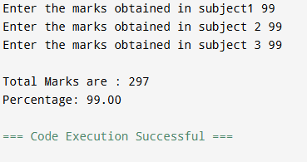

Quesstion 2)

#include <stdio.h>

int main() {

int a, b;

int temp;

printf("Enter the first integer a ");

scanf("%d", &a);

printf("Enter the second integer b ");

scanf("%d", &b);

temp = a;

a = b;

b = temp;

printf("After swapping values: a = %d, b = %d\n", a, b);

}

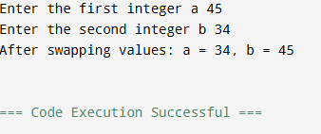

Question 3)

#include <stdio.h>

int main() {

int IntegerValue;

printf("Enter an integer between 65 and 90: ");

scanf("%d", &IntegerValue);

if (IntegerValue >= 65 && IntegerValue <= 90) {

printf("%d = %c", IntegerValue, (char)IntegerValue);

} else {

printf("Error: the input value is not in the given range");

}

}

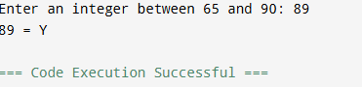

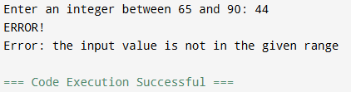

Question 4)

#include <stdio.h>

int main() {

float BasicSalary, HRA, DA,GrossSalary;

printf("Enter the employee's basic salary: ");

scanf("%f", &BasicSalary);

HRA= 0.10 \* BasicSalary;

DA= 0.05 \* BasicSalary;

GrossSalary = BasicSalary + HRA + DA;

printf("\n--- Salary Details ---\n");

printf("Basic Salary: %.2f\n",BasicSalary);

printf("House Rent Allowance : %.2f\n",HRA);

printf("Dearness Allowance : %.2f\n",DA);

printf("Gross Salary: %.2f\n",GrossSalary);

}

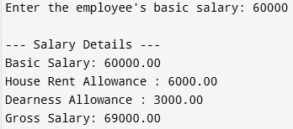

Question 5)

#include <stdio.h>

int main() {

printf("Name: Ali\n");

printf("Age: 20\n");

printf("Course: \"C Programming\"\n");

printf("Result: Passed\n");

}

